MEMORIES OF BARRINGTON ELEMENTARY SCHOOL

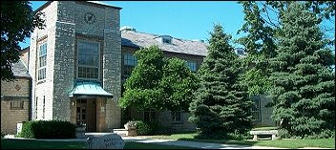

From Garry Hall:

Taking a nap on a rolled up pad on the floor in Kindergarten

The principal patrolling the cafeteria and not letting me leave if my lunch was not finished.

