MEMORIES OF BARRINGTON ELEMENTARY SCHOOL

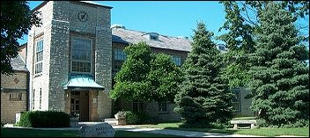

From Rob Boehm:

One of my fond memories was playing 4 Square on the playground. We would play from bell to bell and would sometimes get in trouble if we got too aggressive!
The dress code as I recall was pretty strict, and our shirts always had to be tucked in.

